STUDENT COURSE SYTEM

A Final Project

Submitted to the Faculty of the

Graduate Studies Program

Southern University at New Orleans



In partial fulfilment

Of the requirements for the degree of

Masters of Science

In

Computer Information Systems

Advisor: Dr. Alijani. S. David

By

Hemanth Chowdary Kanuri

Spring: 2016

**ACKNOWLEDGEMENTS**

I am really grateful because I managed to complete my PROJECT within the time given by my guide. I sincerely thank Dr. David. S. Alijani, Professor, Management Information Systems at Southern University at New Orleans for his guidance and encouragement in carrying out this project work.

Working on this project on NAME was a source of immense knowledge to me. I would like to express my sincere gratitude to **Dr. David. S. Alijani** for his guidance and valuable support thought out the course of this project work. I acknowledge with a deep sense of gratitude, the encouragement and inspiration received from our faculty members and colleagues. I would also like to thank my parents for their love and support.

**HEMANTH CHOWDARY KANURI**

**CERTIFICATE OF APPROVAL**

**FINAL PROJECT REPORT**

This is to certify that Final Project Report has been approved by the examining committee for meeting the final project requirement for the Master of Science degree in Computer Information Systems, May 2016.

Project faculty Guide

_____________________________ __________________________

Dr. David. S. Alijani

Research Project Professor, Southern University at New Orleans

_____________________________ __________________________

Dr. Adnan Omar

Research Project Chairperson, Southern University at New Orleans

External Reviewer

____________________________ __________________________

Dr. Igwe Udeh

Research Project Co-Chairperson, Dean, College of Business & Public Administration

**ABSTRACT**

 Accounting and Financial analysis is very important for organizations to keep track of their budgets, their customer accounts and how they stand on the revenue scale for the financial year. It is a process that involves lot of man power and also lot of money. It is known that small scale and medium scale businesses cannot afford the software and costs to bear them. For those reasons, these businesses are turning towards excel to keep a track on their records. Excel is not an efficient tool to handle loads of data and gets really cumbersome as the amount of data increases. This might result in loss of records which may prove fatal.

Hence, to encounter this problem, we have come up with a tool called Fincon. It is a cloud based accounting and financing tool, which can even be accessed from mobile without any hassle of installations. It includes features like income and expense tracker, analysis of the accounts based on the cash generation.

An organization can just register, allowing access for them to use the software. By using the software, the financial decisions can be easily taken by the head of the company, by looking at the data in much more organized manner and will avoid the issues of re-verifying and checking if the data is correct.

**TABLE OF CONTENTS**

LIST OF FIGURES…………………………………………………………………...vi

LIST OF TABLES……………………………………………………………………vii

CHAPTER 1: INTRODUCTION……………………………………………………..1

* 1. Statement of the Problem…………………………………………………...1
  2. Statement of the Objective………………………………………………….1

CHAPTER 2: LITERATURE REVIEW……………………………………………..3

2.1 Framework (Laravel) ..………………………………………………….3

2.2 Server ……………………………………………………………………..

2.3 Front-end ………………………………….………………………………

CHAPTER 3: METHODOLOGY…………………………………………………….5

3.1 System Development………………………………………………………..5

3.2 Admin…………………………………………………….6

3.3 Company Admin…………………………………………...7

3.4 Account Login……………………………......................9

3.5 Head…………………………………………………………..............14

CHAPTER 4: FINDINGS……………………………………………………………18

CHAPTER 5: CONCLUSION……………………………………………………….19

PROGRAM CODE…………………………………………………………………...21

REFRENCES………………………………………………………………………….24

APPENDIX……………………………………………………………………………26

**CHAPTER - I**

**INTRODUCTION**

With financial analysis and maintenance of accounts being an important part of the pie for major organizations, handling all the data in paper becomes too tedious and may result in lots of human error while calculations are done, leading to faulty valuations. To overcome these difficulties, excel has been an option for these organizations. Starting right from data entry that is entering all the data into an excel worksheet is prone to probability of lots of human error.

Even then, the data in an excel spreadsheet or in the database, is difficult to find. It will also become a challenge to keep updating the data as the business, or the accounts or the customer base keeps increasing. Hence resulting in data loss and delay of the reports when needed. This application gathers all the information into one interface and gives the head of the company a chance to view all the financial data giving a better scope to manage the cash flows in and out of the company. This web application gives a dynamic view for top level management. This application being able to be accessed over the cloud, it gives access to data on the go and thereby a chance to take real time decisions anywhere right from their mobiles, rather than having a stack of papers to deal with.

**STATEMENT OF THE PROBLEM**

We all know that in past everything was recorded on papers and kept in files. Time has changed, and with increasing demand for services, and the competition in the market has grown drastically too. This is leading to the need of taking quicker decisions. In this process, going through files would be very time consuming and difficult to check all the documents in detail.  As the business grows bigger, the finance and the data starts to go beyond, and it becomes very difficult to record. The major problem is that, not every company can afford an

ERP or a tally software, or loads of man power for their business. With this web application, all these hassles can be eliminated. This is the real time problem which has started to grow in all the businesses right now. Even with the data growing, this application will make it easy and assure that there is no data loss and also result in decrease in delay of reporting data.

**STATEMENT OF THE OBJECTIVE**

This research project will be helpful for many small businesses or organizations that are interested in keeping track of their financial data. The main objective of this project is, it gives an opportunity to the heads of the company to deal with the financial issues wisely and manage his/her cash flows, expenditures and bills that are to be paid on the go. With this application, all the data can be seen in a single interface, anywhere and anytime eliminating the waste of time and the hassle of papers and files. This application provides a facility to control income and expenditure and will help in taking crucial decisions at the right time.

**CHAPTER - II**

**LITERATURE REVIEW**

This project uses lots of resources in order to be fully functional, and various technologies have been used to complete this project. Code Igniter has been used as the framework. The server is application is made of Apache, and the PHP coding has been used to get the server into action.

The database is developed using the MySQL software and SQL queries have been used to create the database. The front end has been coded and structured using HTML, CSS, JavaScript and

Angular JS. Any of the modern day browsers can be used to run the project.

**Framework (Laravel):**

In computer programming, a software framework is an abstraction in which software providing generic functionality can be selectively changed by additional user-written code, thus providing application-specific software. A software framework is a universal, reusable software environment that provides particular functionality as part of a larger software platform to facilitate development of software applications, products and solutions. Software frameworks may include support programs, compilers, code libraries, tool sets, and application programming interfaces (APIs) that bring together all the different components to enable development of a project or solution. The Laravel framework is an open-source software development web framework, for use in building web sites with PHP. Laravel framework has a few system requirements which are satisfied by the Laravel Homestead virtual machine, so it is highly recommended that homestead is to be used as the local Laravel development environment. While controller classes are a necessary as part of development, models and views are optional. The API (Application Peripheral Index) used is the very well-known Apache. The Apache is used because of its standards and wonderful infrastructure.

**Server:**

In the computing field, a server is a device or program that provides services to other devices called the clients. This is called the client-server model. A single computation across the server can be distributed across all the clients at once and is of tremendous advantage. Few of the services provided by the servers are the data sharing ability, or performing computations for the client. Here, the server used is a database server, and hence it provides database services to its clients. This is accessed through the front end that has been developed using HTML, Angular

JS etc. The database acts as the back end and handles tasks such as data analysis and storage. In a master-slave model, database master servers are central and primary locations of data while database slave servers are synchronized backups of the master acting as proxies. Most of the

Database servers works with the base of Query language. Each Database understands its query language and converts it to Server readable form and executes it to retrieve the results. Here

SQL queries have been used to create the database server.

**Front-End:**

The interface between the user and the data access layer is called the front-end. There are several layers between the hardware and the end user, and in the front end deals with abstraction, simplifying the product by providing a user-friendly interface. Here the front-end that is the interface between the user and hardware is a webpage and hence it is developed using HTML, Angular JS and JavaScript. A webpage is created so that the user inputs can be read and thereby appropriate results that are analyzed and stored in the database can be displayed.

**CHAPTER - III**

**METHODOLOGY**

In an organization, numerous transactions happen in a day. There are times when huge amounts of data need to be updated and it becomes hard to store and perform the analysis in an excel sheet. It will be a hectic process in the fast moving world and would take lot of time in finding a specific data whenever needed. Considering a medium size company and their affordability, this web application can be useful in many ways to save a lot of time in entering data entry and updating. The employees can also have a closer look at their company’s expenditures, incomes and all the transactions that take place. Having an application like this will benefit the organization.

**System Development**

1. Problem Definition – Brainstorming is a key element in identifying the problem. The problem identified here is that the head of the company needs to keep track of his company’s financial attributes such as incomes, expenditures to take critical decisions.
2. Physical Design – This relates to the data flows.
3. Logical Design – This relates to the actual input of the data into the application and is stored in the database. This is shown with all the forms, reports.
4. Programming and Organization – Programming deals with the coding which is used for deployment of the system to the web. Organization relates to having correct data in correct table.
5. Tests and Implementation – Running tests of the application to assure its working and is secure and user friendly.
6. Operation – The application is put in place for the users to use it.
7. Evaluation – Feedback is taken from the system users and the response is taken into consideration for further developments.

As we discussed earlier in the system development the steps are explained in an elaborated way below.

The main part of this application is that for any company who needs to monitor their transactions, expenditures and income.

**Admin:**

For this application, an admin will exist and he will be the one responsible for creating users. The role of the admin is to monitor the companies that wish to be a consumer of this particular application. Once a company decides to use this application, he gives them a unique username and password to use the software. The admin will create an admin login for the admin of that particular company.

There will be an accountant login and there will be head login as well and the functions of these will be discussed further.

**Company admin:**

In the company admin login given to the company, this the page where the user of this application enters the data.

* A company admin can create access to any member of the company ranging from the employee to the head.
* To create the users the admin has to fill out the form giving out the necessary details of that particular user.
* The admin can add all the bank accounts which are associated with the company and can give out all the details of the banks in the form requested.
* The admin can add the expenditure types for the company namely salaries, bank interests etc.
* The other functionality is that he can even add the income types for the company and can save them.

**Account Login:**

The accountant provides a wide-range of professional assistance and counselling to companies at all stages of their listing process. The main functionalities are:

* On login, the data includes expenditure parties, income sources consisting name, description, and the type of an expenditure or the income.
* Also lists the details of an expenditure which includes Name, Account Type (Main/Sample), Payment Type (Bank interest, Bills, etc.,), Repeat Type (Daily, Weekly, Monthly) and finally the amount of their expenditure.
* The accountant has full access to the expenditure table, where he can add all the details regarding the expenditures made by the company. He enters data about what the company is making an expenditure for, and to whom it is making. He can also record the date of the expense, and if it is a weekly, or a monthly expense. An expenditure can be deactivated, if it is no longer required.
* Income page in the Account portal gives the details of income of the company. It also includes details such as where the income has been received, when it has been received.
* Details of all the transactions are recorded and are displayed on the interface.
* The data once entered can be deactivated at any time, by clicking on the deactivate button.
* The next functionality is the transactions; they can always add the transactions to this table. They can perform one-time payments as non-recurring transactions.

**Head:**

* In spite of anything and everything, considering all the above information, the final decision is made by the Head. (i.e., Approved/Rejected)

**Project Resources Identification**

|  |  |
| --- | --- |
| Framework | Laravel |
| Server Application | Apache |
| Server side / Scripting Language | PHP |
| Database | MySQL |
| Query Language | SQL |
| Front End Languages | HTML, CSS, JavaScript, Angular Js |
| Browser | Chrome, Explore, Safari |

**Server Application**

The Apache HTTP Server Project is an effort to develop and maintain an open-source HTTP server for modern operating systems including UNIX and Windows. The goal of this project is to provide a secure, efficient and extensible server that provides HTTP services in sync with the current HTTP standards. Apache supports a variety of features, many implemented as compiled modules extend the core functionality.

**XAAMPP**

XAMPP is regularly updated to incorporate the latest releases of Apache, PHP, MariaDB and Perl. It also comes with a number of other modules including OpenSSL, phpMyAdmin, WordPress and more. Self-contained, multiple instances of XAMPP can exist on a single computer, and any given instance can be copied from one computer to another. XAMPP is offered in both a full and a standard version (Smaller version).

Officially, XAMPP's designers intended it for use only as a development tool, to allow website designers and programmers to test their work on their own computers without any access to the Internet. To make this as easy as possible, many important security features are disabled by default.XAMPP has the ability to serve web pages on the World Wide Web. A special tool is provided to password-protect the most important parts of the package. XAMPP also provides support for creating and manipulating databases in MariaDB and SQLite among others.

Once XAMPP is installed, it is possible to treat a local-host like a remote host by connecting using an **FTP** client. Using a program like FileZilla has many advantages when installing a content management system (CMS) like **phpMyAdmin**. It is also possible to connect to local-host via FTP with an HTML editor.

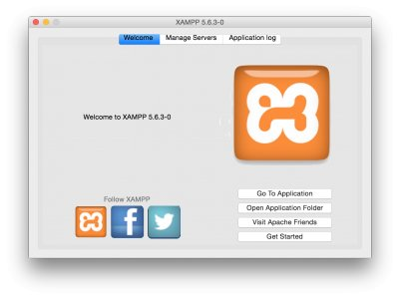

Figure 1 XAMPP SETUP

Starting Apache and MySQL

Once the setup is complete, if you open the XAAMPP application and go to manage servers and click on start all button to start to start the following.



Figure 2: Starting apache server and My SQL

**phpMyAdmin Setup**

**phpMyAdmin** is a free and open source tool written in PHP intended to handle the administration of MySQL or MariaDB with the use of a web browser. It can perform various tasks such as creating, modifying or deleting databases, tables, fields or rows; executing SQL statements; or managing users and permissions.

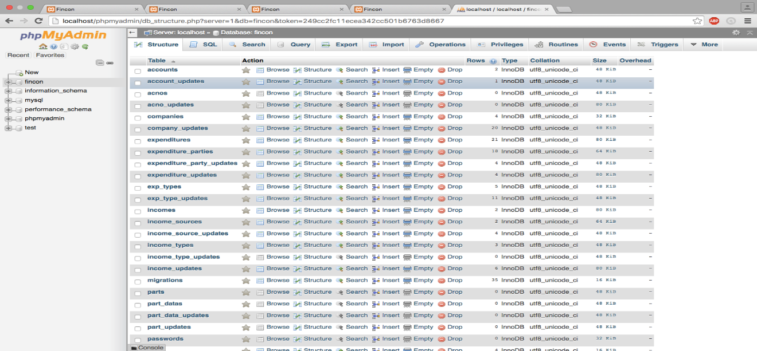

Figure 3: PHP My Admin

**PHP** is a scripting language designed to fill the gap between SSI (Server Side Includes) and Perl, intended for the Web environment. This enables developers to create powerful applications that can publish a blog, remotely control hardware, or run a powerful website such as Wikipedia. Of course, to accomplish something such as this, you need a database application such as MySQL. **PHP** can also be used to build **GUI**-driven applications.

**CHAPTER IV**

**IMPLEMENTATION AND RESULTS**

1. **Admin login**

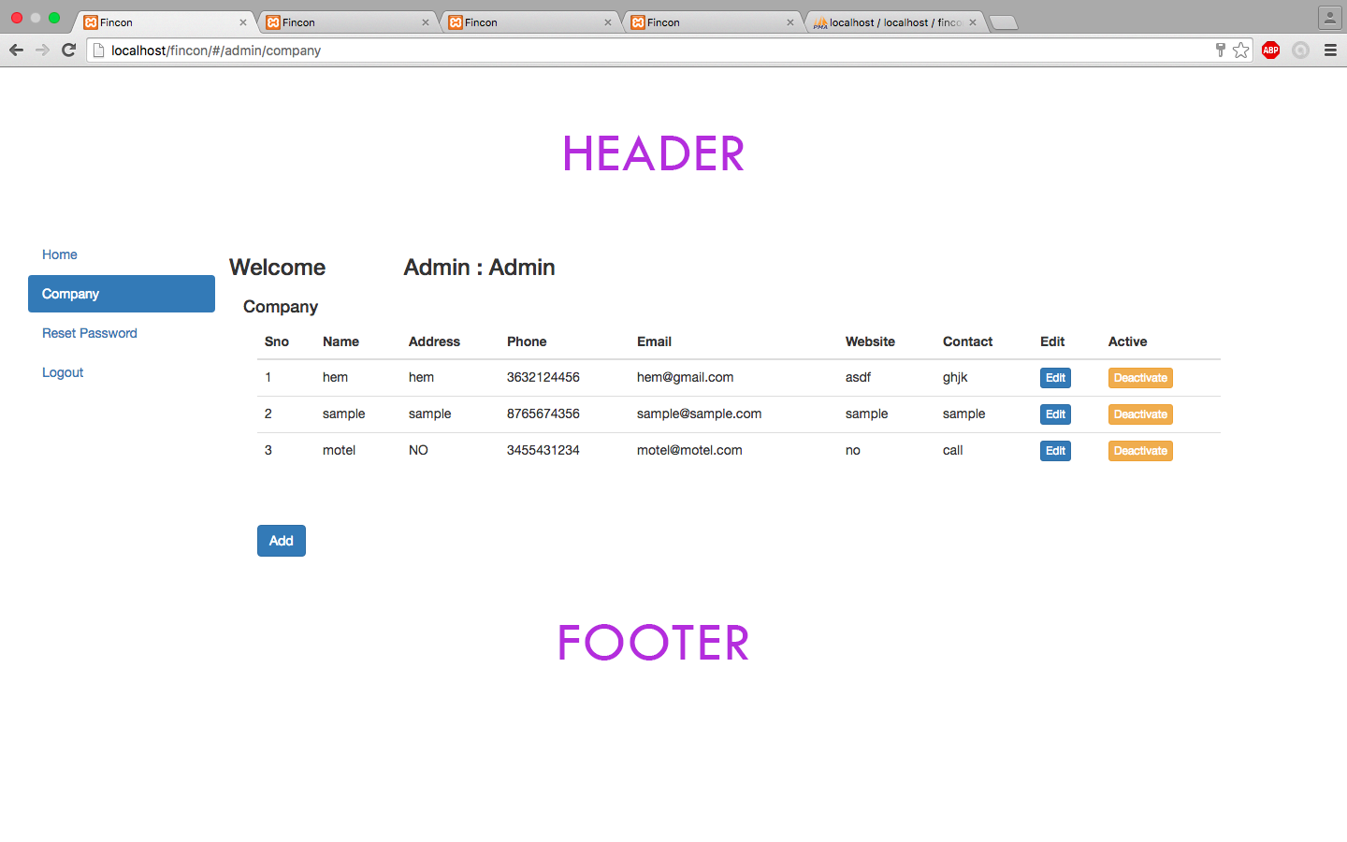

Figure 4: Admin login

This is the admin login page where the admin creates the companies who wish to use this application.

1. Admin login consists of following functions

In this page the Admin adds the companies who wish to use the application



Figure 5: adding companies

**Password update**

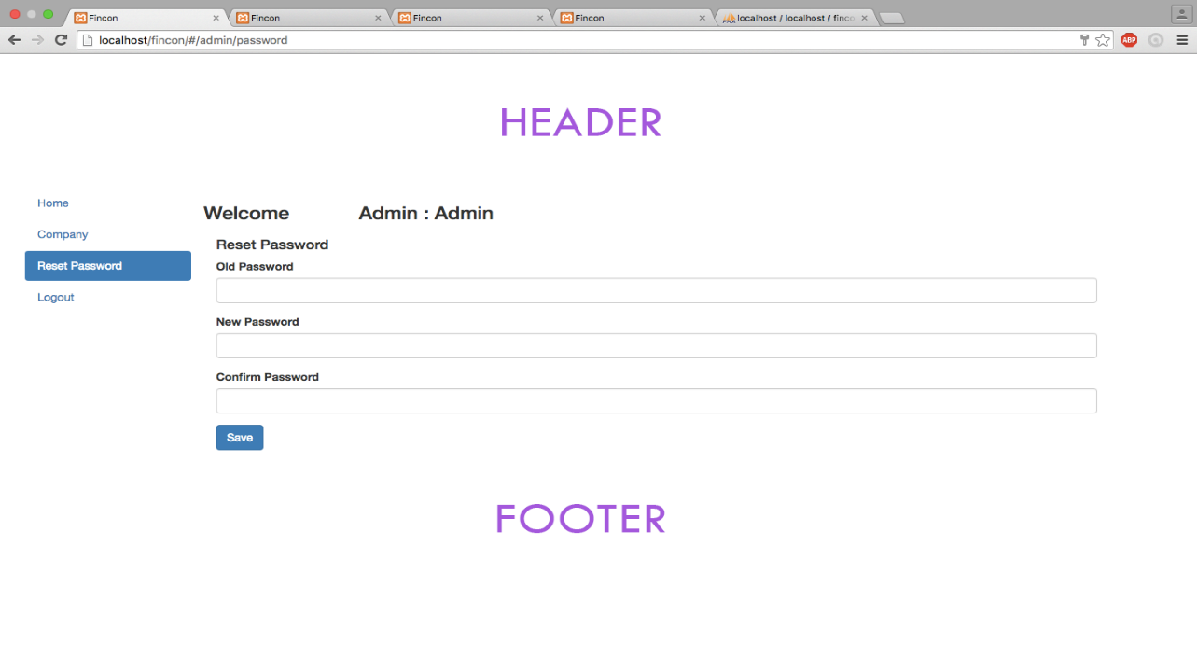

Figure 6: update password

1. Company Admin login

**Functions of Company admin are**

**Creating users**

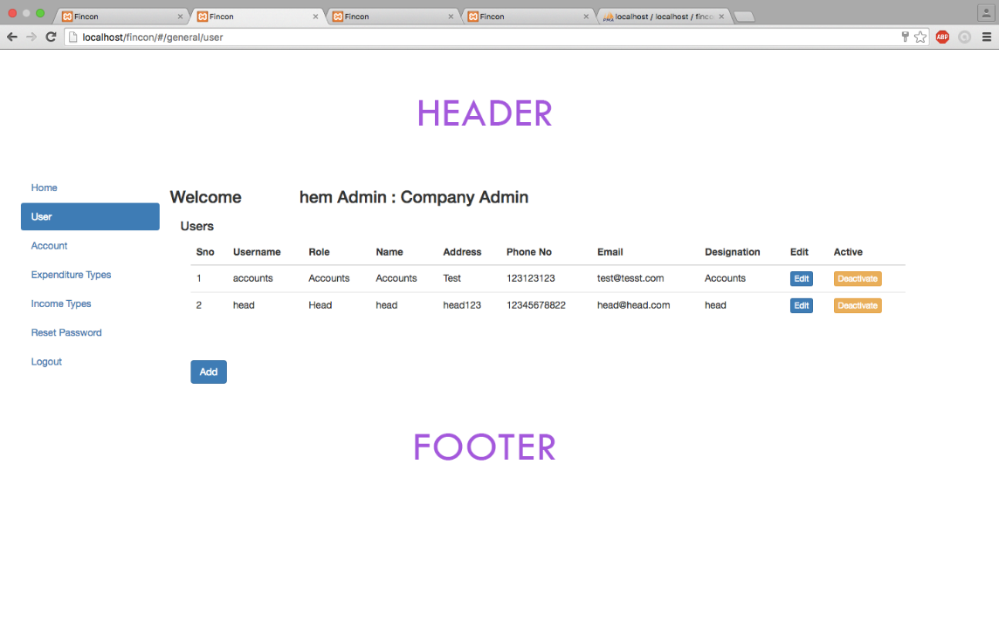

Figure 7: Creating users

**Adding accounts**

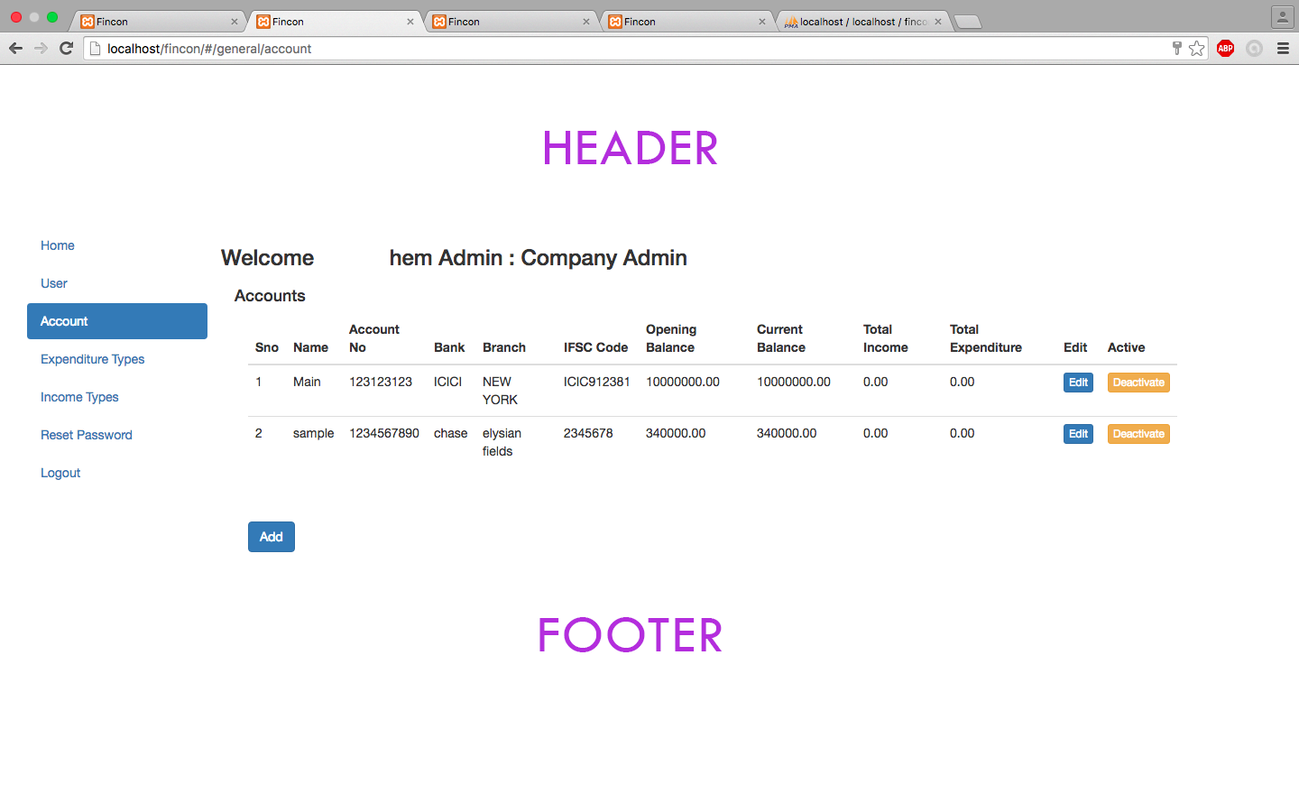

Figure 8: Adding accounts

**Adding Expenditure types**

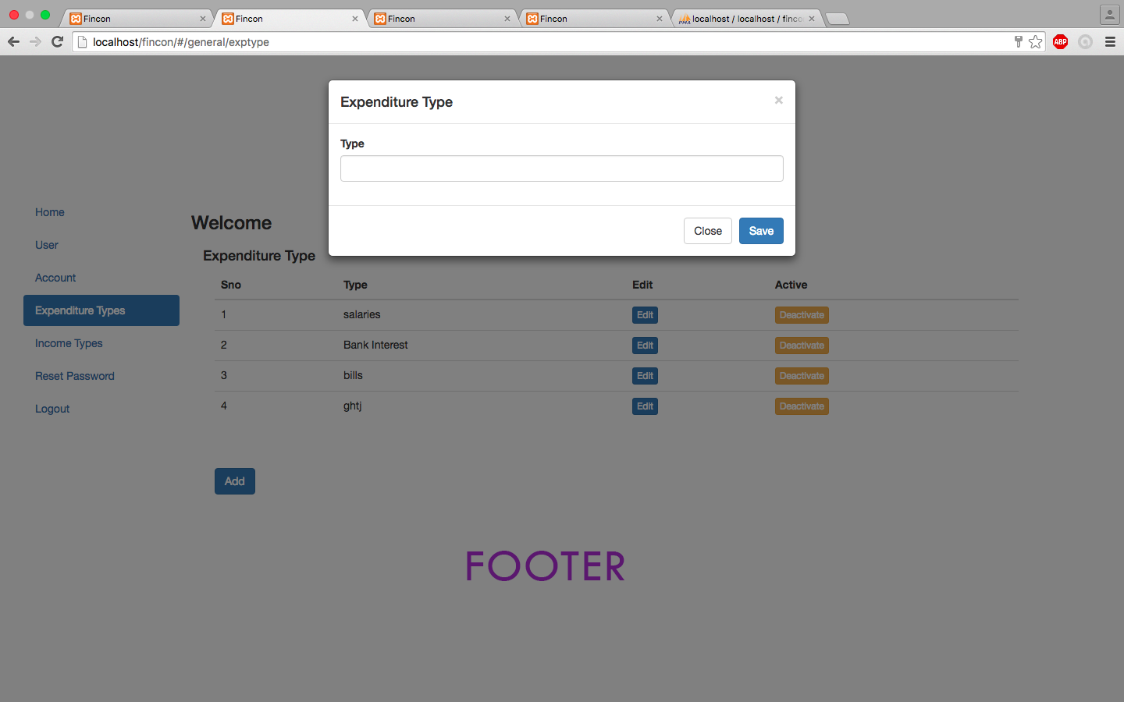

Figure 9: Adding Expenditure types

1. Accountant login

Some functions in this are

**Adding income sources**

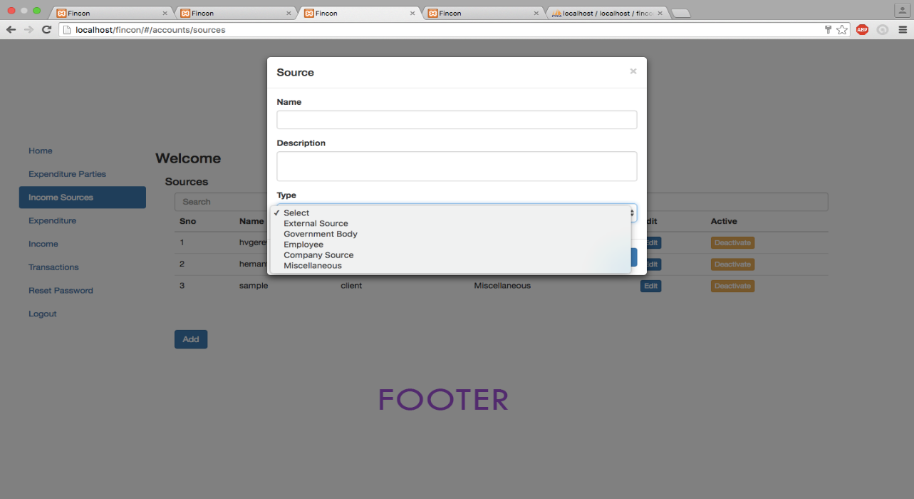

Figure 10: Adding Income Sources

**Adding Expenditures with recurring payments**

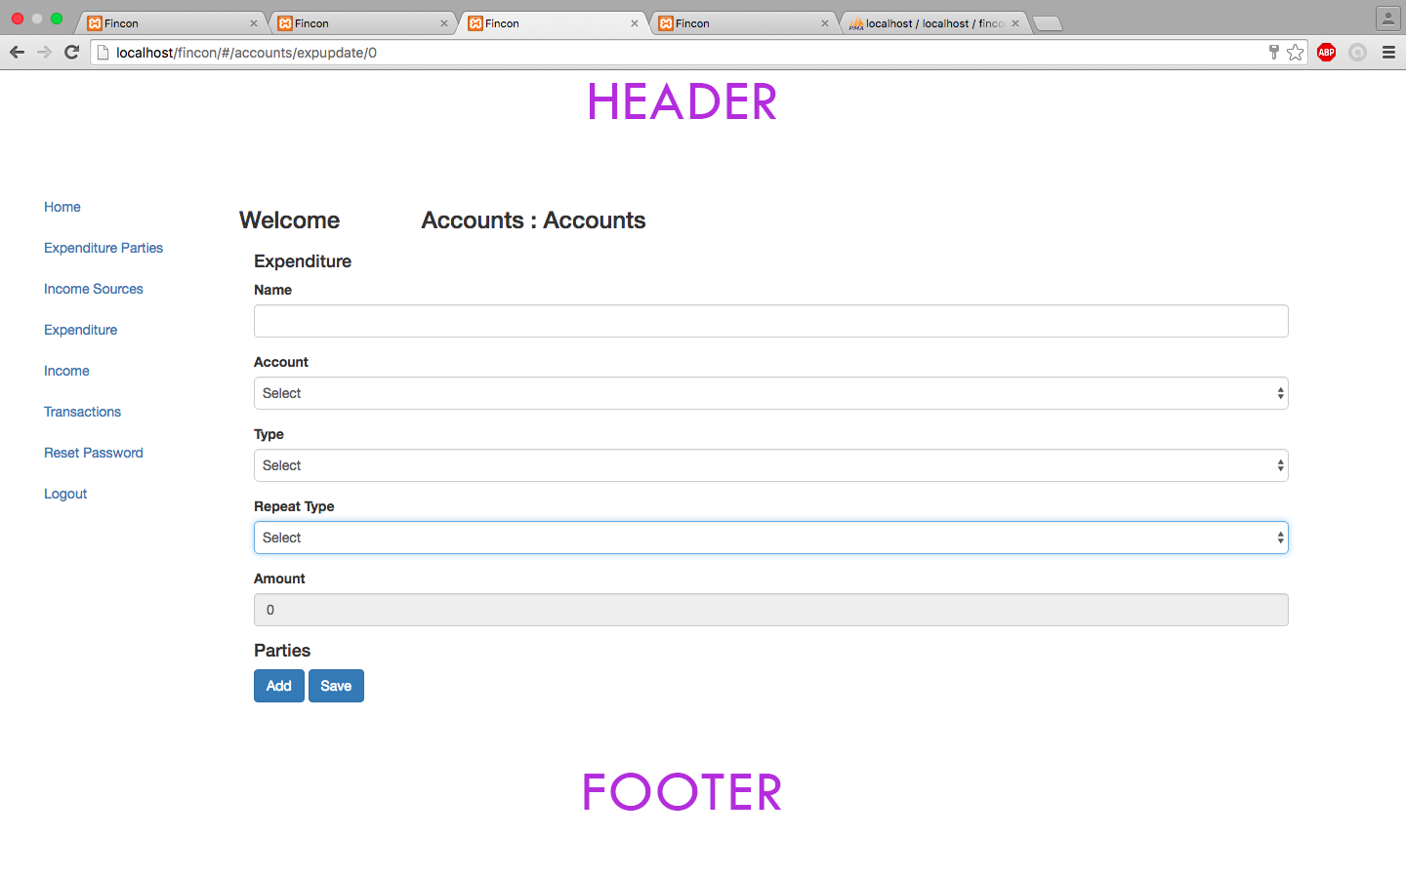

Figure 11: Adding Expenditures

**FINDINGS**

In an organization, various exchanges happen in a day. There are times when gigantic measures of information should be redesigned and it turns out to be difficult to store and perform the examination in an exceed expectations sheet. It will be a frenzied procedure in the quick moving world and would take part of time in finding a particular information at whatever point required. Considering a medium size organization and their reasonableness, this web application can be valuable from numerous points of view to spare a ton of time in entering information section and overhauling. The representatives can likewise have a more critical take a gander at their organization's consumptions, salaries and every one of the exchanges that occur. Having an application like this will advantage the association.

Accounting and Financial examination is imperative for associations to monitor their financial plans, their client records and how they remain on the income scale for the money related year. It is a procedure that includes part of labor furthermore a lot of money. It is realized that little scale and medium scale organizations can't manage the cost of the product and expenses to endure them. Thus, these organizations are turning towards exceed expectations to keep a track on their records. Exceed expectations is not a productive apparatus to handle heaps of information and gets truly cumbersome as the measure of information increments. This may bring about loss of records which may demonstrate lethal. Henceforth, to experience this issue, we have thought of a device called Fincon. It is a cloud based bookkeeping and financing instrument, which can even be gotten to from versatile with no bother of establishments. It incorporates highlights like salary and cost tracker, examination of the records in view of the money era.

An association can simply enlist, permitting access for them to utilize the product. By utilizing the product, the budgetary choices can be effortlessly taken by the leader of the organization, by taking a gander at the information in significantly more sorted out way and will maintain a strategic distance from the issues of re-confirming and checking if the information is right.

**CONCLUSION**

I would like to conclude by saying that this web application comes as a respite to those organizations that cannot afford large man power and ERP systems to maintain accounts or to perform financial analysis for the organization. This application comes to the aid of them, and keeps track of all expenditures, incomes and transactions happening from the company. This solves the hassle of paper work, and makes it easy for the heads of the organizations to take critical decisions. With this application being hosted from the cloud, it becomes even easier to access these reports on the go from the mobile. This software can revolutionize the times to come. The program has been tested, and it is working.